Table of Contents

Scrutinise — Search Strategy (v3)
Status: living document. Authoritative reference for the search stack; cite by section number in CC briefs. Update as work lands and pilots return data. Last revised: 6 August 2026 (v3 — major update: the stream model expands from five corpora to the full ~15-row set actually held or planned §3.1; “graph” splits into a proper taxonomy of distinct graphs, including two new people-centred graphs, §9; the mechanism/principle graph is reframed as a cross-cutting lens rather than a searchable row §9.3; statistics search is clarified as headings-searchable / values-callable §6d; the §3.2 dependency-chain diagram is now an actual image; the whole roadmap is refreshed against what has genuinely shipped since 28 June — the router is live, the FTS crisis is fully resolved, and vector-in-legislation is the live experiment.) This revision documents design and architecture. Day-to-day operational history — exact commits, dated incidents, before/after numbers — lives in CHANGE_LOG.md and handoff_summary.md; this file stays the durable “what and why,” not the run log.
Scrutinise lives or dies by search quality, so search decisions are made empirically, not by intuition. This document sets out what we are building, in what order, why, and how each piece fits with the others.

1. Governing principles
- Measure against the gold set, always. No search change ships on a hunch; it ships because it moved the number. The gold set itself must be trusted before its numbers are — the answer keys need a human validation pass, and any baseline measured across an index change (a rebuild, a dedup) is void and must be retaken. This is not a one-off caveat; it recurred twice in July/August and is now a standing rule.
- Separate cheap-reversible decisions from expensive-sticky ones (§2). Pilot the sticky ones on a subset before committing at full scale.
- The corpus is ground truth. The LLM frames the search and writes the answer, but never asserts a fact the corpus did not return.
- Web is for orientation; the corpus is for the law you cite. X/social content sits a tier below even web — signal, never a fact source (§6d.1–6d.4 in the retained v2.1 detail).
- Index by function and outcome, not only by subject and citation — the design stance behind the stream model (§3) and the graph taxonomy (§9).
- Every component is config-driven and flag-gated, default OFF, flipped only once the gold set rewards it. This has now been the actual, proven mechanism for every layer shipped (expansion, router) and the one still gating vector.
- Alternatives considered are recorded, so rejected options are visible and revisitable.
- A sprint brief handed over verbally is a sprint brief that can be lost. A brief given only in a CC conversation and never written to SPRINT.md (or a named BRIEF_*.md) does not survive a /clear — this happened for real in August. Every brief gets written to disk before it is trusted to still exist next session.
- One shared resource, one owner at a time, recorded somewhere durable when it changes hands — the corpus_fts/corpus_vec handover between the Lex and Search threads worked precisely because this was made explicit; it will keep mattering as more threads run in parallel (search, ingest/stats, Lex/UX are all concurrent as of this revision).

2. The core distinction — is vector “deterministic like FTS”? No.
(Unchanged from v2.1 — retained for continuity.) Keyword FTS (BM25) is cheap and reversible: tune it, measure it, move on. Vector search is a quality continuum dominated by two sticky choices — the embedding model and the chunking — both executed via pilot → measure → commit (the June/July bake-off: gemini-embedding-001 @768d won; no legal-specialist premium from voyage-4). De-risked by piloting, never a one-shot bet.

3. The per-corpus stream model

3.1 The full stream set — far larger than the original five
The original design named five streams (legislation, debates, committees, case law, guidance). That undercounted what we actually hold or plan to hold, and the gap matters: each row below is a genuinely different kind of material with a different retrieval purpose, even where several currently share the same underlying mechanism (keyword search over a tier filter).
Stream | Kind | Purpose — what we want from it | Status
Legislation (primary + SI + retained EU) | specific | the precise law to amend/add/revoke | ✅ live
Debates (Hansard) | specific→principle | the issues behind the law; contested views on causes | ✅ live
Committees | specific→principle | evidence and hypotheses on causes & effects | ✅ live
Case law | specific + graph | how courts interpret the law; real-world edge cases | ✅ live
Guidance (general regulatory/HMRC soft law) | specific | how a regulator currently expects compliance | ✅ live
Quangos | specific→principle | how arms-length bodies act, where they diverge from the parent policy | held, not yet its own row
Codes (statutory codes of practice) | specific | binding-but-not-legislative practice standards | held under guidance today; deserves separating
Regulations (sector rulebooks — FCA Handbook, Ofcom codes) | specific | the operative rules a regulator actually enforces, distinct from the SI that empowers it | held under guidance today; deserves separating
Tax (HMRC manuals, tax tribunal, tax treaties) | specific | the tax-specific law/practice, big and specific enough to be its own row | held under guidance today
Tax simplification (OTS reviews) | principle | where the tax system’s own complexity was diagnosed and what was recommended | held under evaluations today
Special investigations/inquiries | principle | how the civil service and public bodies actually behave; where it goes wrong | not yet built (§9 principle streams)
Outcome/evaluation reports (NAO, PAC, post-legislative scrutiny) | principle | where laws succeed and fail; general principles of effective law | not yet built
Treaties (uk-treaties, uk-treaties-fcdo, parliament-treaties) | specific | international commitments and their domestic scrutiny history | ingested, not yet its own routed stream
Members’ Interests | specific (feeds people-graphs) | declared interests — a political-risk and people-graph input, not searched for its own sake | ingested, not yet wired
Statistics (catalogue only) | specific, headings-searchable | discover which numeric series exists; values are called, not searched (§6d) | ingested, catalogue-index pending a stability prerequisite
Two kinds of stream, unchanged as the load-bearing distinction: specific-retrieval streams want the exact item (search by topic, ranked hits); principle-retrieval streams want transferable patterns (search by failure-mode vocabulary, return clustered lessons). Most of the rows above are specific; the principle streams (special investigations, outcome/evaluation reports, tax simplification) are architecturally different and genuinely unbuilt — see §5.

3.2 Reassembly is a dependency chain, not a merge
The streams are the skeleton of the agentic research loop: one stream’s output becomes another’s query.
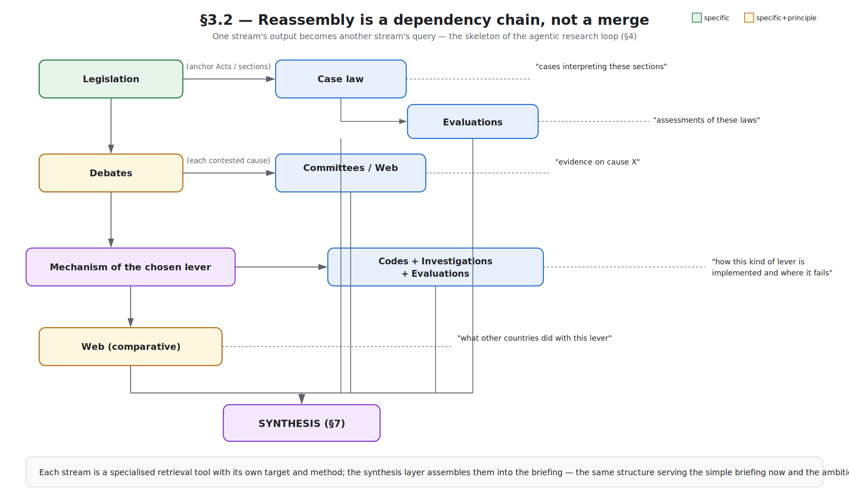
Reassembly is a dependency chain — legislation feeding case law and evaluations, debates feeding committees/web, the chosen lever’s mechanism feeding codes/investigations/evaluations, web comparison, all converging on synthesis
Each stream is a specialised retrieval tool with its own target and method; the synthesis layer assembles them into the briefing — the same structure serving the simple briefing now and the ambitious policy-model later. A stream earns its place only when the gold set shows it improves the result.

4. Target architecture — status refreshed
user idea ──▶ 0. ORIENTATION (web+X, §6d) [NOT STARTED]
──▶ 1. QUERY UNDERSTANDING / ROUTER (LLM) [LIVE — flipped 4 Aug]
expand + decide WHICH stream(s) + tailor the query per stream
──▶ 2a–2n. PER-STREAM RETRIEVAL
keyword (BM25) [LIVE, all wired streams]
vector (semantic) [IN FLIGHT — legislation stream only, being wired now]
graph(s) [see §9 — plural, mostly not yet general-purpose]
──▶ 3. FUSE (weighted RRF) [TUNED on pilot subset; needs re-tune post-rebuild]
──▶ 4. RERANK (cross-encoder) [NOT STARTED]
──▶ 5. SYNTHESIS (Lex) — What/So What/Now What [LIVE]
──▶ 6. AGENTIC RE-SEARCH? [LATER]
The router (step 1) does two things, not one: it decides which streams a query belongs to, and it rewrites the query for each — both matter, and a scoped caller that skips stream selection must still receive the rewrite (a real bug found and fixed in August: a tier-scoped caller was skipping the router entirely and losing its query-tailoring benefit along with the stream-selection it didn’t need).

5. Layer roadmap — status as of this revision
# | Layer | Status
1 | Keyword FTS + citation resolver + legislation boost | ✅ LIVE
2 | Lex adapter | ✅ LIVE
3 | Query expansion | ✅ LIVE (concept queries; verified still load-bearing against Gemini’s shifting defaults)
3.5 | Query router (5 text streams: legislation, debates, committees, case law, guidance) | ✅ LIVE — flipped 4 Aug 2026. Measured: the worked “data protection” query went from nothing (legacy path) → 4 wrong documents (new path, router off) → the correct Act (new path, router on).
3.6 | Three legacy call sites (idea-chat, LegislationPanel, browse) repointed through the gateway | ✅ LIVE, 4 Aug — closes the gap where the fast index existed but users never reached it
4 | FTS index — freshness, coverage, hygiene | ✅ RESOLVED, 4–5 Aug. Coverage gap (rows never indexed) fixed; latency crisis (26s→~0.3–0.9s) fixed; duplicate/orphan hygiene done (19,161 rows removed). See §1’s standing rule about re-baselining after.
4.5 | Act-level metadata table (corpus_acts) | ✅ LIVE, 4 Aug — 250,808 instruments, self-reconciling
5 | Vector / semantic (hybrid + RRF) | 🔶 IN FLIGHT — the live experiment now. Full-corpus embed built; being wired into the legislation stream only first (one stream at a time, §3.1), gold-measurement held pending the answer-key validation pass
6 | Reranker | ⬜ next after vector proves itself
7 | Tier 1 graphs (citation/amendment) | ✅ LIVE, 5 Jul — rescission traversal, archetype D un-floored
7.5 | People-graphs (social/political-actor, committee/witness, interests-register — new, §9) | ⬜ designed this revision, not yet built
8 | Statistics catalogue (headings-searchable) | ⬜ blocked on a stable series key (ingest-side prerequisite)
9 | Principle streams + the mechanism/principle lens | ⬜ post-pilot; genuinely different build, not wiring (§9.3)
10 | Web/X orientation | ⬜ not started

6. Layer detail

6a–6c. (Unchanged from v2.1 — query expansion, embedding model choice, reranker. See prior
revision for full detail; nothing here has changed except status, reflected in §5 above.)

6d. Statistics — headings are searchable, values are callable, not the same thing
The precise distinction, corrected in this revision: the numeric observations themselves (the ~29,000 individual figures) are never full-text-searched — they’re called, once you already know which series you want, via the stats tool. What genuinely is searchable is the catalogue — the row and column headings that describe what a series is: dataset title, measure, COFOG function, geography, time span, department. That catalogue is small, textual, and belongs in the same discovery mechanism as everything else — a statistics stream whose job is “does a relevant series exist,” handing off to the stats tool for the actual numbers once one is identified.
Forward-compatibility note: the catalogue will grow new headings over time that are not raw ingested fields — derived measures (ratios, growth rates, per-capita figures) computed on top of the base data. The catalogue index must be able to add these as new discoverable headings, not just index what’s been ingested today.
Known prerequisite, not yet resolved: the series identifier isn’t currently stable across re-ingest (already caused one real duplication bug). A deterministic seriesKey is needed on the ingest side before the catalogue index is built on top of it — retrofitting afterwards is the expensive version.

7. Synthesis structure — What / So What / Now What
(Unchanged from v2.1.)

8. (reserved — see §9)

9. Graph strategy — a plural taxonomy, and one important reframing
The single biggest correction in this revision: “graph” was never one thing, and treating it as one column undercounted the design space badly. There are multiple genuinely distinct graphs, over different kinds of nodes, answering different questions — and one of the things we’d called a graph isn’t really a searchable content type at all.
Our edge remains the same: existing legal search serves lawyers looking up what the law is; Scrutinise serves reformers trying to change it — so we index function and outcome, and now also people and their involvement, not only subject and citation.

9.1 Explicit / structural graphs (factual, cheap, high precision)
- Citation / amendment graph — ✅ BUILT. Section-to-section legal relationships (amends, repeals, commences, cites, made-under). Powers the rescission-impact traversal.
- Metadata / key-theme graph — department, policy area, instrument type, year. Cheap, queued.
- Quango/regulator-oversight graph (new) — which body regulates which area, and what created it. Ties the quangos row (§3.1) to the legislation that empowers it.

9.2 People-centred graphs — genuinely new, added this revision
(Prompted directly by Charlie’s own instinct: “a social graph — what an MP or parliamentarian has voted on or been involved in or debated.” This is a real gap, not a refinement.)
- Social / political-actor graph (new) — an MP or peer’s votes, debate contributions, and general involvement in a topic over time. Directly the data behind “who will kick up a fuss” — the political-risk question the rescission report has always wanted to answer, now with a real data source rather than inference.
- Committee/witness graph (new) — who sat on which committee, who gave evidence to which inquiry. Extends the social graph from voting into institutional participation.
- Interests-register graph (new) — declared interests (from the Members’ Interests corpus), directly useful for the same political-risk question and for conflict-of-interest flags on any given policy area.

9.3 The mechanism / principle lens — reframed, not a graph among graphs
This is a correction to the model itself, not just a new entry. The mechanism/principle “graph” (tagging provisions by what kind of lever they are — duty-to-report, licensing regime, sunset clause — and connecting matches across unrelated subjects) does not deserve its own row or column. It has two parts: first, a genuinely vector-like step (learn a representation of “what kind of lever this provision is,” not what it’s about); second, a graph connecting provisions sharing that tag. But the result isn’t a corpus you retrieve documents from — it’s a cross-cutting lens you apply while searching legislation, case law, or evaluations, e.g. “show every implementation of a duty-to-report, in any domain, and how each fared.” It sits across the other streams, not beside them. This is the backbone of the principle-retrieval streams (§3.1) once built.

9.4 Other inferred / content graphs (LLM-extracted; confidence-tagged)
- Intent / problem→lever graph — problem → claimed causes → chosen lever → outcome. A per-Act version already runs at query time inside the rescission report’s political layer.
- Institutional-outcome / failure-pattern graph — provision → delivery body → failure mode → outcome. The future public evidence campaign plugs in here.
- Argument / contested-cause graph — who claimed what causes what, over Hansard.
- Case-law doctrine graph (new) — how a legal principle evolved through a sequence of judgments, distinct from a simple case-cites-case edge; tracing an idea, not a citation.
- Lineage-of-attempts graph — bills (incl. failed/withdrawn) → Acts → amendments → repeals, threaded over time on one problem.

9.5 Behavioural (needs traffic)
- Co-interest graph — discovered from engagement once there is real usage.

9.6 Discipline (unchanged)
Explicit before inferred; every inferred edge carries provenance and confidence; each layer gates on the gold set; content graphs land after vector + reranker (a graph over weak retrieval is weak); the lens (§9.3) is applied only once the streams it cuts across are themselves solid.

10. The seam, the type taxonomy, and the callers
(Unchanged from v2.1 in substance. §10.3’s caller list has grown since — LEGAL_LANDSCAPE, POLICY_ALTERNATIVES, AD_HOC_RESEARCH now exist as live Lex-side intents, all going through the one gateway, per the Lex-thread’s own handover discipline. Operational detail lives in handoff_summary.md, not duplicated here.)

11. Evaluation, A/B, and feedback signals
(Unchanged in method — offline gold-set scoring remains the instrument. Reinforced this revision: the gold set’s answer keys need a human validation pass that has never happened, and now — after the FTS coverage fix and the duplicate/orphan cleanup both changed what the index actually returns — any baseline gathered before the validation pass is void twice over, not once. This is the single highest-leverage non-build task outstanding on the whole project.)

12. Immediate next steps (refreshed 6 August 2026)
- The gold-key validation pass (Charlie). Gates everything below with numeric confidence. Now genuinely urgent — two separate index changes since the answer keys were drafted.
- Vector wired into the legislation stream — build/scoping in progress; full measurement held until step 1 lands.
- corpus_vec carries the same orphan drift corpus_fts just had cleaned out of it — found, not yet fixed. Fold into the vector work rather than treat as separate.
- The 15 deliberately-retained “stale” rows in corpus_fts — Charlie’s policy call, low urgency.
- Statistics catalogue — blocked on the ingest-side stable series key; the search-side stream is scoped and ready once that lands.
- One at a time from here, per stream: legislation+vector first (in flight), then the next text stream, then the people-graphs (§9.2), then the principle streams + lens (§9.3) as a real design-and-build project, post-pilot.
- Every sprint brief gets written to SPRINT.md or a named file before it’s trusted to survive a session clear — a real near-miss this month, now a standing rule (§1.8).
One sentence: run specialised streams across a genuinely plural set of corpora and graphs, treat the mechanism/principle layer as a lens rather than a row, let the LLM frame and finish, and never ship — or baseline — a change the gold set didn’t reward.

